**Deployment of App in IBM Cloud**

**Upload the Image to IBM Container**

|  |  |
| --- | --- |
| Team ID | PNT2022TMID36311 |
| Project Name | Nutrition Assistant Application |

# Creating Repository in IBM Cloud

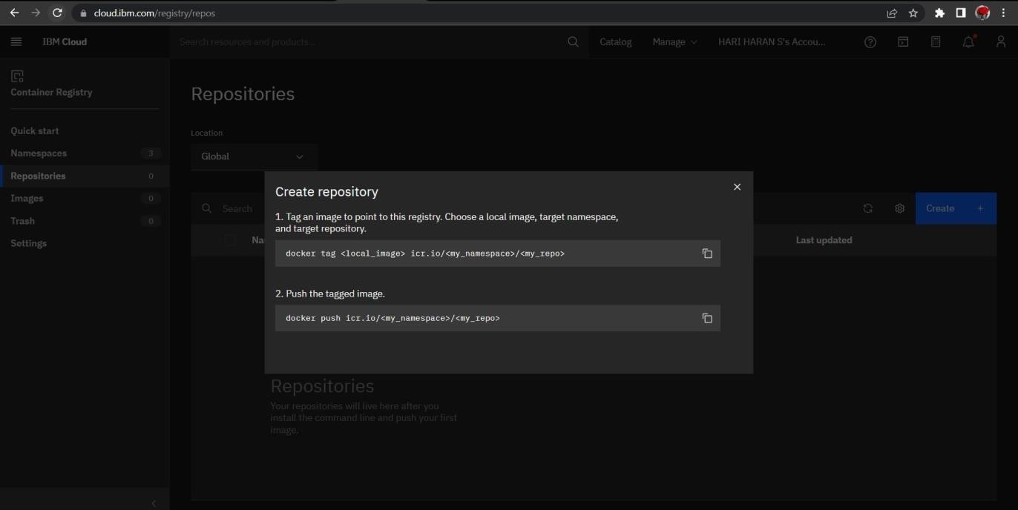

**Upload Inage to IBM Cloud Registry**

